# **BHAGWAN MAHAVIR COLLEGE OF MANAGEMENT**

## **Progress Report - 2**

## **Student Details:**

| **Program & Semester** | **Enrollment Number** | **Name** |
| --- | --- | --- |
| MCA SEM-4 | 2205030201016 | Devani Shani R. |
| MCA SEM-4 | 2205030201035 | Kaklotar Jaydeep R. |
| MCA SEM-4 | 2205030201047 | Patel Akshitkumar A. |

# **System Design & Development**

in this report, we will see System Design & Development. Using use case diagram, Class Diagram, Interaction Diagram, Activity Diagram, and Coding Standards.

## **Index:**

* Use Case Diagram
* Class Diagram
* Interaction Diagram
* Activity Diagram
* Coding Standards

## **Use Case Diagram:**

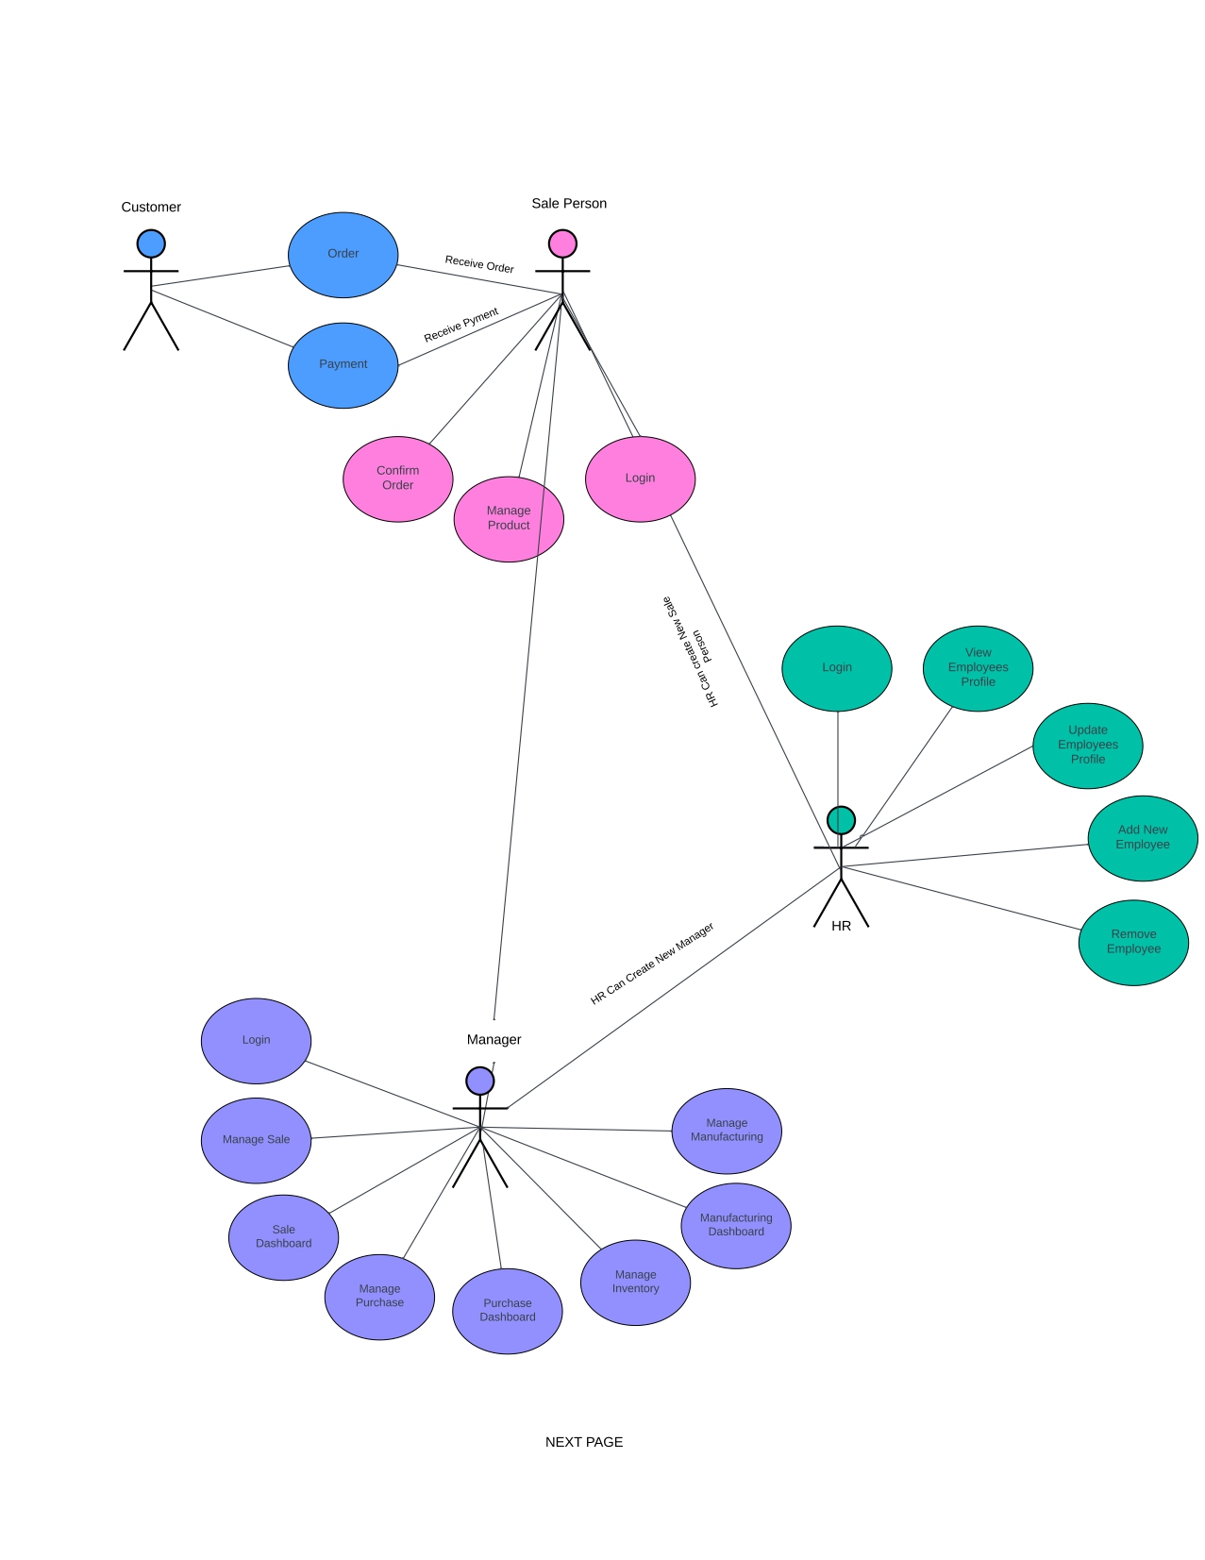

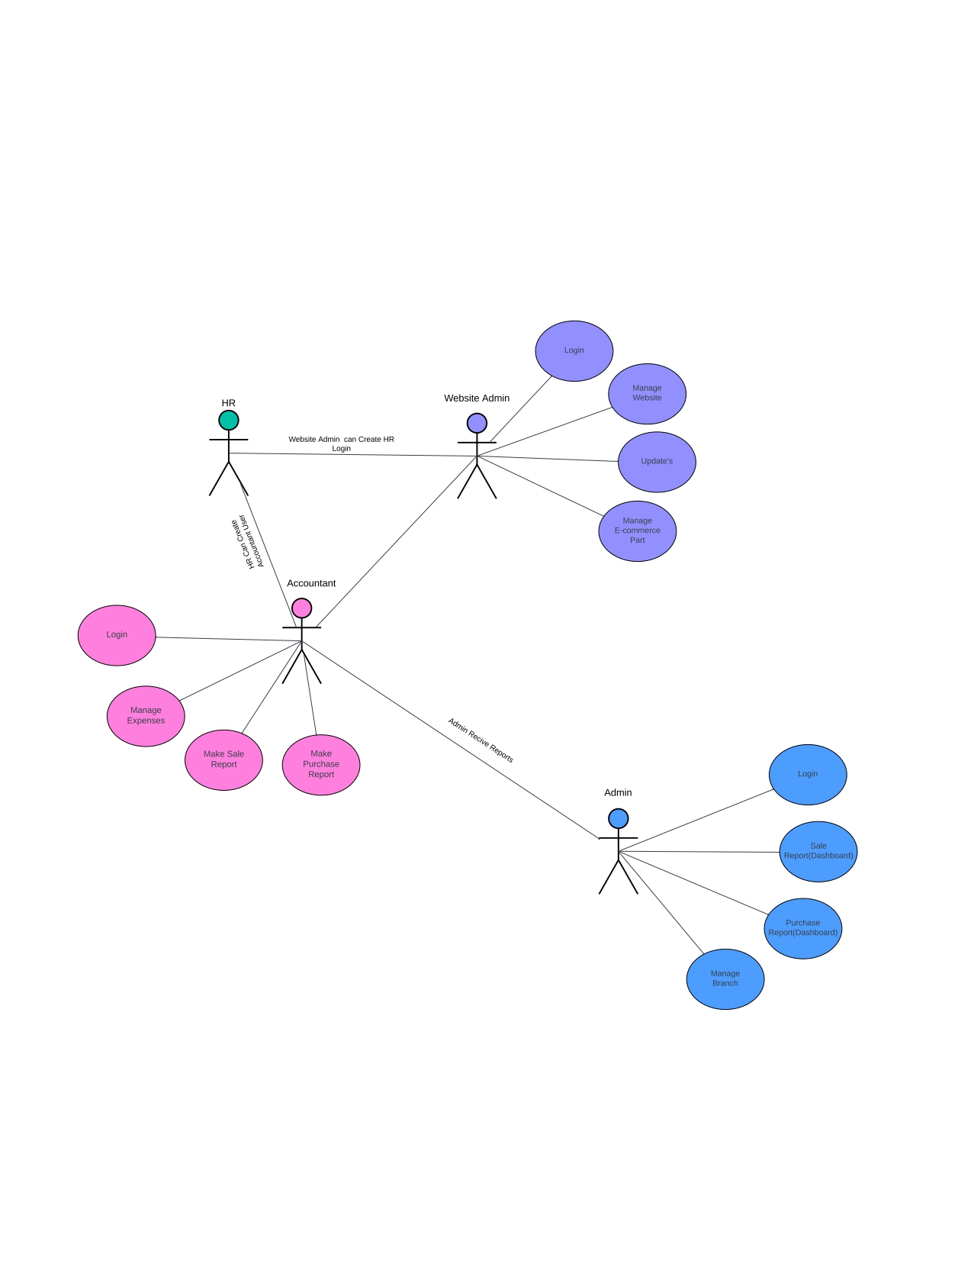

## **Class Diagram**

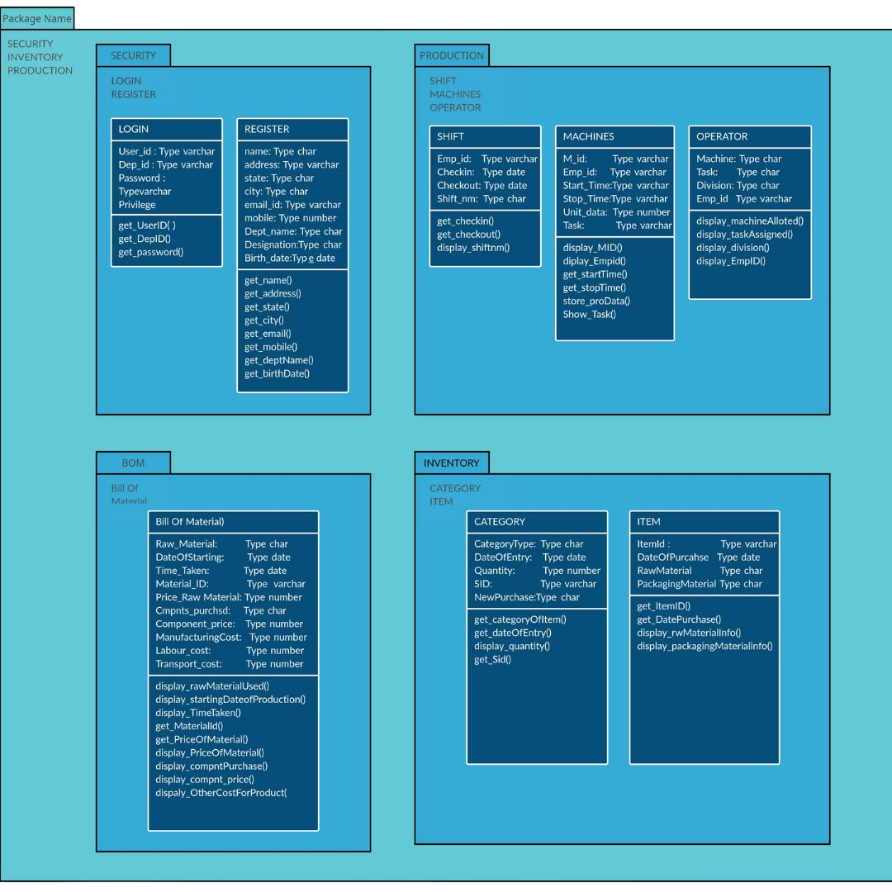

## **Interaction Diagram**

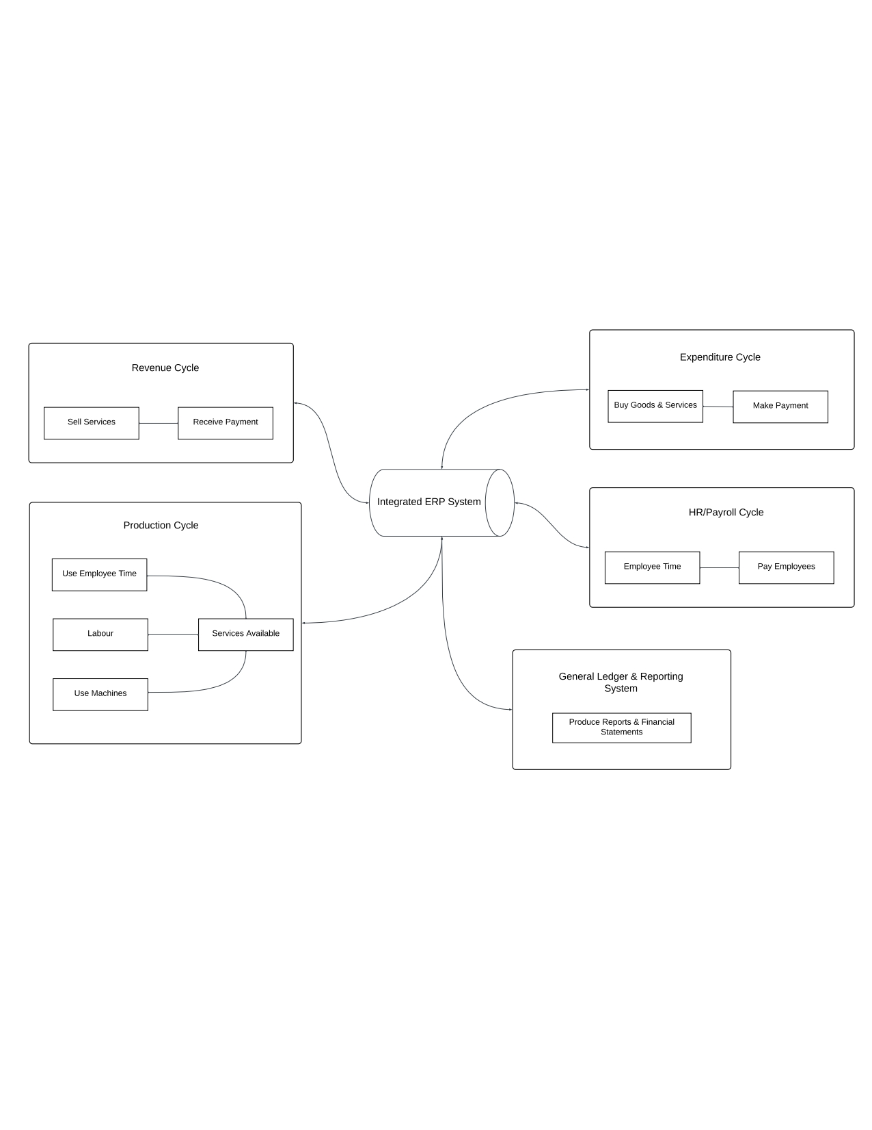

## **Activity Diagram**

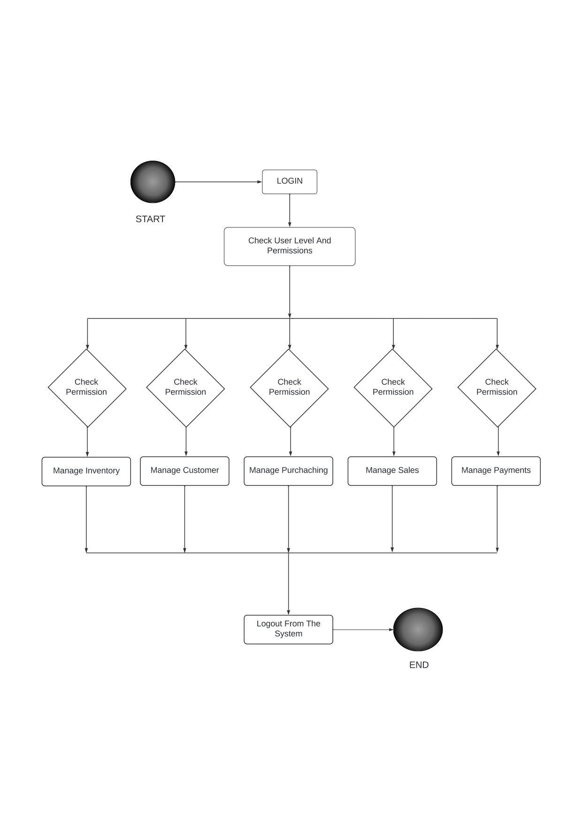

## **Coding Standards**

### **README.md**

* + Write a comprehensive README file that explains the purpose of the project, how to set it up locally, how to run tests, and any other relevant information.
  + Include badges for build status, code coverage, and other pertinent metrics.
  + Provide clear instructions on how to contribute to the project and the contribution guidelines.

### **Code Comments**

* + Use meaningful variable, function, and component names to make the code self-explanatory.
  + Add comments to complex sections of code, algorithms, or where the code might not be immediately obvious to others.
  + Follow a consistent commenting style throughout the project.

### **Dependencies**

* + 'base', 'sale_management', 'account', 'crm', 'stock', 'purchase', 'point_of_sale', 'mrp','hr_expense', 'hr_holidays', 'hr_recruitment', 'maintenance', 'hr', 'calendar', 'im_livechat', 'hr_attendance', 'lunch', 'hr_contract','ks_dashboard_ninja'

### **Folder Structure**

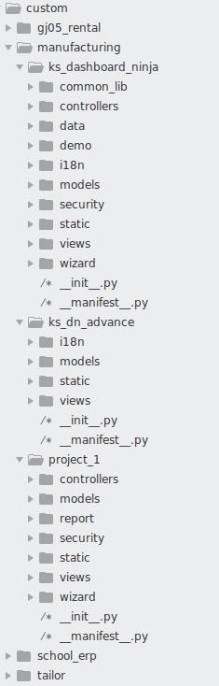

**Date:** 20 – 03 - 2024

**External Guide Details**

**Name:** Mr. Mayank Rameshbhai Chanllawala

**Signature:**